1.0 INTRODUCTION
1.1ABOUT THE SYSTEM
Apartment Visitors Management System deals with the security at society premises from unauthorized or unwanted visitors and provides an entry pass to the regular visitor.
Nowadays, in most society visitor management consists of visitors scribbling their name in a paper book.
Instead, Apartment Visitors Management System will assist you in the professionalized way in which you welcome your visitors. This software is a complete Visitor Management service to improve the efficiency, productivity and security.

2.0 NEED FOR THE SYSTEM
The purpose of developing an apartment visitor management system is to computerize the traditional way of visitors. Another purpose for developing this application is to generate the report automatically. The main aim of this application is to develop a system that effectively manages all the data related to apartment visitors which helps gate guards to maintain bulk records of visitors. The purpose is to maintain a centralized database of all visitor information. The goal is to support various functions and processes necessary to manage the data efficiently.

3.0 BACKGROUND STUDY
3.1 EXISTING SYSTEM
In present all visitor works are done on paper. The whole yearly visitor is stored in the registers. We can’t generate reports as per our requirements because it takes more time to calculate the visitors’ report.
3.2 DRAWBACKS
- Not user friendly: The present system is not user friendly because data is not stored in structure and proper format.
- Manual Control: All report calculations are done manually so there is a chance of error.
- Lots of paperwork: Details about Visitors are maintained in the register, so lots of paperwork is required.
- Time consuming
3.3 PROPOSED SYSTEM
Apartment Visitor Management system is a web-based technology that will revolutionize the way your society manages visitors and provide visitor pass to them. Visitor Management system is more important to security guards or security society. This web application provides a way to effectively control record & track society visitor traffic.

4.0 PROBLEM FORMULATION
4.1 MAIN OBJECTIVES
The main objective of the project is to store and manage details of visitors and generate passes for them.
4.2 SPECIFIC OBJECTIVES
The specific goal of the project is to develop a system that will store the visitors' details and generate passes. Specifically, the project aims for the following objectives: It helps store all the visitor's data systematically. It also helps generate passes for visitors who regularly visit any apartment. All access is given to admin. Data-wise reports can be generated to search for any specific visitor or number of passes created within a specific time period.

4.3 METHODOLOGY
Methodology means the analysis of principles of methods, rules and postulates employed by a discipline. The methodology used for this system is the Linear sequential model or the Waterfall model. The Waterfall model suggests a systematic sequential approach to software and development that begins at the system level and progresses through analysis, design, coding, testing and maintenance. Model after conventional engineering cycles the model encompasses the following activities.
4.4 PLATFORM SELECTION
Hardware Requirements:
SL NO | NAME | HARDWARE
1 | Processor | IntelCoreDuo2.0 or more
2 | RAM | 2 GB or more
3 | Hard Disk | 10 GB or more
4 | Keyboard | Standard windows keyboard
5 | Monitor | LCD / LED
6 | Mouse | Compatible Mouse
Tool/Platform/Software:
SL NO | NAME | SOFTWARE
1 | Platform | PhpMyAdmin
2 | Front-end | HTML, CSS, JavaScript
3 | Back-end | PHP, MySQL
4 | Development Language | PHP

5.0 SYSTEM ANALYSIS & DESIGN
5.1 SYSTEM ANALYSIS
In the context of an Apartment Visitors Management System, system analysis involves studying the existing visitors' managements processes, identifying the requirements and goals of the system, and defining the scope of the new system. This phase includes gathering information from stakeholders, understanding their needs, and analyzing the current workflows. The output of this analysis will be a detailed system requirements specification document that outlines the functionalities and features required for the Apartment Visitors Management System.
A system is simply a set of components to accomplish an objective. Developing a new system, investigating the operation, and making possible changes in the existing system are called System Analysis. The analysis comprises a detailed study of various operations performed by a system and their relationships within and outside the system. It is the process of gathering and interpreting facts, diagnosing problems and improving the system using the information obtained.
The Objectives of System Analysis include the following.
● Identifying user needs.
● Performing economic and technical analysis.
● Establishing cost and scheduled constraints.
Here the system analyst should study a system with an eye to solving its problem using computers. It is an essential part for the development of a project by a system analyst. System Analysis is for finding out what happens in the existing systems, deciding on what changes and new features are required and defining exactly what the proposed system must be. This process of system analysis is largely concerned with determining developing and agreeing the user’s requirements. It provides prime opportunities to communicate well with the user and conceived a joint understanding of what a system facility is using interactive techniques. To analyze a system, one must study the system's work in detail. The System Analyst has to understand the functioning and concept of the system in detail, before designing.

5.2 FEASIBILITY ANALYSIS
Feasibility analysis for an Apartment Visitors Management System assesses the viability and practicality of developing and implementing the system within the organization. It includes technical, economical, and operational feasibility assessments.
A feasibility study is really a small-scale systems analysis. It differs from a full analysis only in its level of detail. The study involves analyst in most of the tasks of a full system analysis but with a narrower focus and more limited time. The result of the study helps the user to decide whether to proceed, amend, postpone or cancel the project, particularly important when the project is large, complex and costly. However, a feasibility study is no substitute for a full, detailed and thorough analysis of a client's system. Different people can provide different parts of the answers in a feasibility study; those who initiated study, the technical experts, and those who will have to use the new system. The job of the analyst is to pull all this information together and present it to the client in the form of a coherent report. Detailed investigation of operational and procedural activities during a feasibility study is very limited. On the contrary, software feasibility has four solid dimensions:
Technology – Is a project feasible? Is it within the state of art? Can defects be reduced to a level matching the application’s need?
Finance – Is it financially feasible? Can development be completed at a cost the software organization, its client or the market can afford?
Time – Will the project’s time-to-market beat the competition?
Resources –Does the organization have the resources needed to succeed? The feasibility study report has to address three levels of feasibility. They are:
- Technical Feasibility
- Economic Feasibility
- Performance Feasibility
- Operational Feasibility
- Functional Feasibility
- Social Feasibility
5.2.1 TECHNICAL FEASIBILITY
Technical analysis in the context of an Apartment Visitor Management System involves evaluating the technical aspects and requirements of the system. This includes assessing the necessary hardware software infrastructure, determining compatibility with existing systems, evaluating scalability and performance requirements, considering security measures, and ensuring integration with other relevant systems. The technical analysis helps determine if the organization has the technical capabilities to develop, implement, and maintain the Apartment Visitors Management System effectively.
Technical Analysis is the study of function, performance and constraints that may affect the ability to achieve an acceptable system. The considerations that are normally associated with technical feasibility include development risk and technology. It involves financial considerations to accommodate technical enhancement. Technical analysis must be based on an out-time design of system requirements in terms of input files, programs and procedures. This must be qualified in terms of volume of data, frequency of updating, cycles of activity etc. in order to give.
5.2.2 ECONOMICAL ANALYSIS
Economic analysis is the frequently used method for evaluating the effectiveness of the system. The cost/benefits that are expected from the system are compared with the tools. If benefits outweigh the tools, the decision is to be made. If it is to have a chance of being approved. The system reduces the unnecessary expenses and wastage of man hours by its capability. Economic analysis for an Apartment Visitors Management System focuses on assessing the financial feasibility and cost-effectiveness of implementing the system. This involves estimating the development costs, including hardware, software, and personnel, as well as the ongoing operational costs such as maintenance, training, and support. The analysis also considers potential cost savings, revenue generation, and return on investment (ROI). The goal is to determine if the benefits derived from the Apartment Visitors Management System outweigh the costs and if the system is financially viable for the organization.
5.2.3 PERFORMANCE ANALYSIS
Here we should examine the functions of the system which may work properly when it is implemented. The proposed system does not involve complex protocols. It has a simple working style. A basic knowledge of computers is all that is required. Hence the proposed system is functionally feasible.

6.0 SYSTEM DESIGN
6.1 INPUT DESIGN
Input design is the link that ties the information system into the world of its users. The input design involves determining the inputs, validating the data, minimizing the data entry and providing a multi-user facility. Inaccurate inputs are the most common cause of errors in data processing. Errors entered by the data entry operators can be controlled by input design. The user-originated inputs are converted to a computer-based format in the input design. Input data are collected and organized into groups of similar data. Once identified, the appropriate input media are selected for processing. All the input data are validated and if any data violates any conditions, the user is warned by a message. If the data satisfies all the conditions, it is transferred to the appropriate tables in the database. In this project the visitors' details are to be entered at the time of registration. A page is designed for this purpose which is user friendly and easy to use. The design is done such that users get appropriate messages when exceptions occur.
6.2 OUTPUT DESIGN
Computer output is the most important and direct source of information to the user. Output design is a very important phase since the output needs to be in an efficient manner. Efficient and intelligible output design improves the system relationship with the user and helps in decision making. Allowing the user to view the sample screen is important because the user is the ultimate judge of the quality of output.
6.3 DATABASE DESIGN
6.3.1 DATA FLOW DIAGRAM
LEVEL - 0
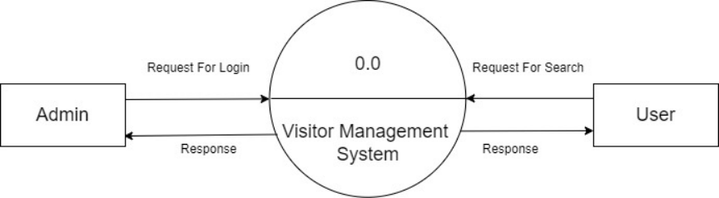

LEVEL -1 DFD FOR ADMIN MODULE

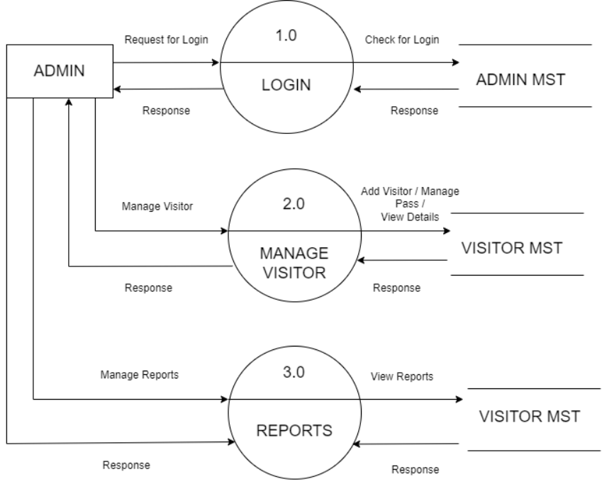

LEVEL - 1 DFD FOR USER MODULE

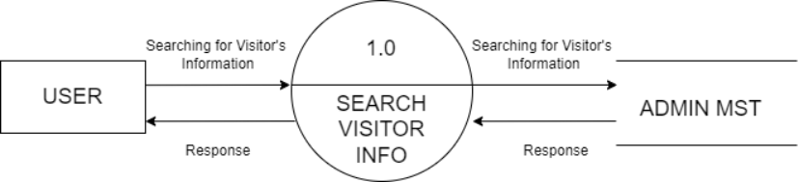

LEVEL - 2 DFD FOR MANAGING VISITORS IN ADMIN MODULE

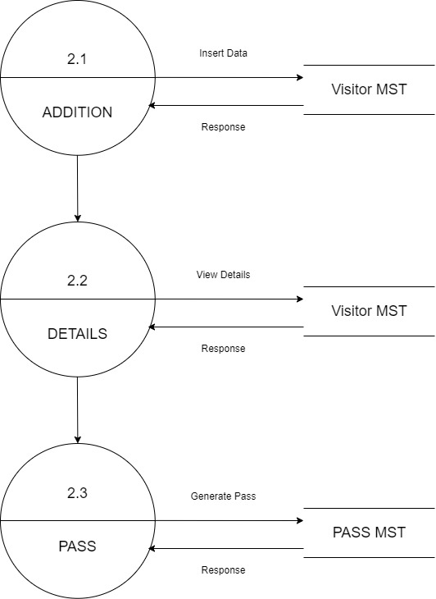

LEVEL - 2 DFD FOR VIEWING REPORTS IN ADMIN MODULE

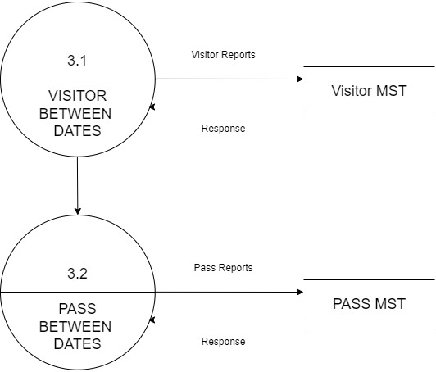
LEVEL - 2 DFD FOR SEARCHING VISITORS INFORMATIONS FROM USER MODULE

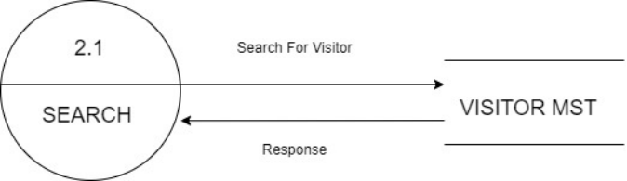

6.3.2 ER DIAGRAM

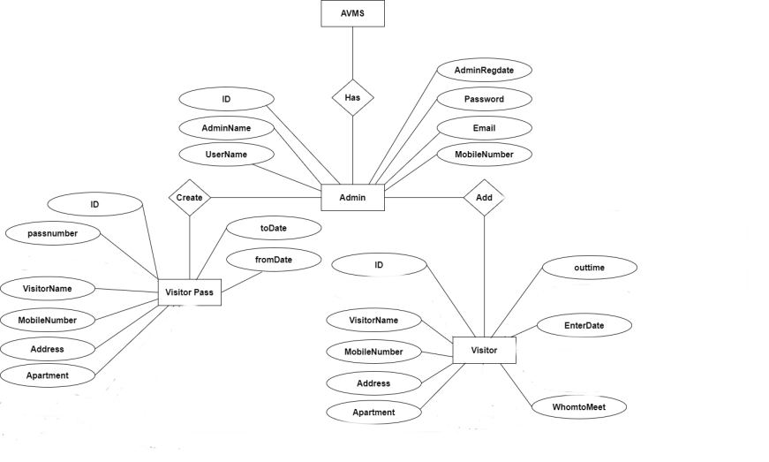

6.3.3 TABLE DESIGN

ADMIN TABLE
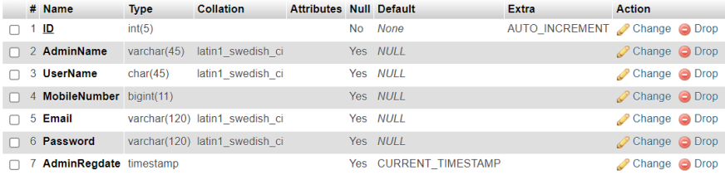

VISITORS TABLE
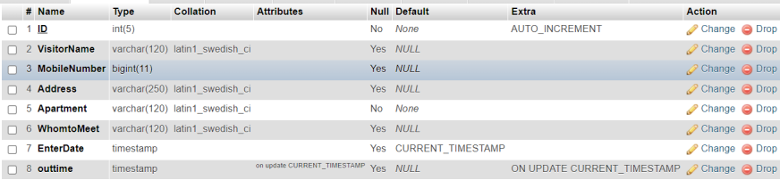

PASS TABLE
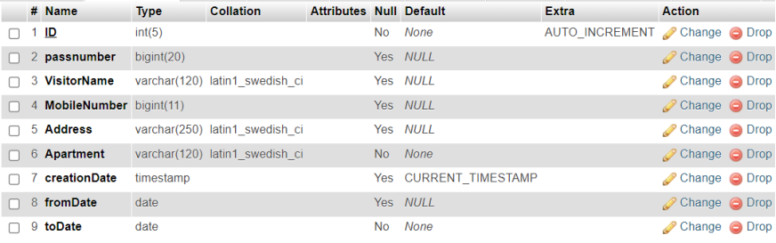

7.0 SYSTEM TESTING AND IMPLEMENTATION
7.1 SYSTEM TESTING
Software Testing is the process used to help identify the correctness, completeness, security, and quality of developed computer software. Testing is vital to the success of the system. System Testing makes the logical assumption that if all the parts of the system are correct, the goal will be successfully achieved.
System Testing is a critical element of software quality assurance and represents the ultimate view of specification, design, and coding. The user tests the developed system and changes are made according to their needs. The testing phase involves the testing of the developed system using various kinds of data.
There are many approaches to Software testing, but effective testing of complex products is essentially a process of investigation, not merely a matter of creating and following rote procedures. One definition of testing is "the process of questioning a product in order to evaluate it", where the "questions" are things, the tester tries to do with the product, and the product answers with its behavior in reaction to the probing of the tester. The quality of the application can, and normally does, vary widely from system to system but some of the common quality attributes include reliability, stability, portability, maintainability and usability.
The Software and Hardware are integrated, and a full range of system tests is conducted in an attempt to uncover errors at the Software/Hardware Interface. System testing is a series of different tests whose primary purpose is to fully exercise the computer-based system. Although each test has a different purpose, all the work should verify that all system elements have been properly integrated and performed allocated functions. System testing is the stage of implementation, which is aimed at ensuring that the system works accurately and efficiently before live operation comments. Testing is vital to the success of the system to be correct, and the goal will be successfully achieved. The entire software has been tested with available data and it has been found that the expected output forms are generated by the system. It is now ready for implementation.
7.2 MAINTENANCE
Maintenance is a characteristic of design and implementation, which is expressed, as the probability that an item will be retained in or restored to a specific condition within a given period of time when maintenance is performed in accordance with the prescribed procedures and resources.
Maintenance is the enigma of system development. It holds the software industry captive, tying up programming resources. Analysts and programmers spend far more time maintaining programs than they do writing them.
Maintenance can be classified as corrective, adaptive, or prefecture. Corrective maintenance means repairing processing or performance failures or making changes because of the previously uncorrected problem or false assumptions. Adaptive maintenance means repairing processing or performance or modifying the program to respond to the user’s additional or changing needs. Of this type of more time and money are spent on prefecture than on corrective and adaptive maintenance.
Technical and management approach to the maintenance phase can be implemented with little upheaval. However, tasks performed during the software engineering process define maintainability and have an importance on the success of any maintenance approach.
Maintenance activities employed in this project are:
Corrective Maintenance: Corrective maintenance removes the software faults in our project. Corrective maintenance should be of overriding priority for software maintenance which improves the system without changing its functionality.
Adaptive Maintenance: Adaptive Maintenance was used because of changes in the user requirements, changes in the target platform or changes in the external interface.
Perceptive Maintenance: Perspective maintenance was done to prevent failure and optimize the software; adaptive maintenance modifies the software to keep it up to date with its operation.

8.0 CONCLUSION
This Application provides a computerized version of Apartment Visitor Management System which will benefit the society of gate guards who must maintain a bulky and very hard to maintain record books for all visit who visit in the society for various reasons.
It makes the entire process online and can generate reports. It has a facility for staff login where staff can fill in the visitor details and generate reports.
The Application was designed in such a way that future changes can be done easily. The following conclusions can be deduced from the development of the project.
- Automation of the entire system improves productivity.
- It provides a friendly graphical user interface which proves to be better when compared to the existing system.
- It gives appropriate access to the authorized users depending on their permissions.
- It effectively overcomes the delay in communications.
- Updating information becomes so easier.
- System security, data security and reliability are the striking features.
- The System has adequate scope for modification in future if it is necessary.

9.0 SCOPE FOR FURTHER DEVELOPMENT
The current system is capable of registering new visitors and managing their datas. It is also capable of creating passes which will allow visitors to enter the apartment without entering any kind of details for a certain duration of time.
Also, the current system does not provide any kind of support for visitors who visit for a shorter period of time or who visit one time only, for example delivery people. This shows the scope to extend the project.

10.0 BIBLIOGRAPHY
https://www.w3schools.com/php/default.asp
https://www.sitepoint.com/php/
https://www.php.net/
https://www.mysql.com/
http://www.mysqltutorial.org
https://www.wampserver.com/en/download-wampserver-64bits/

11.0 APPENDIX
11.1 SCREEN SHOTS
LOG-IN PAGE
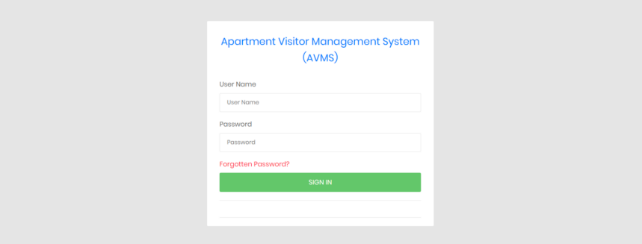

FORGOT PASSWORD
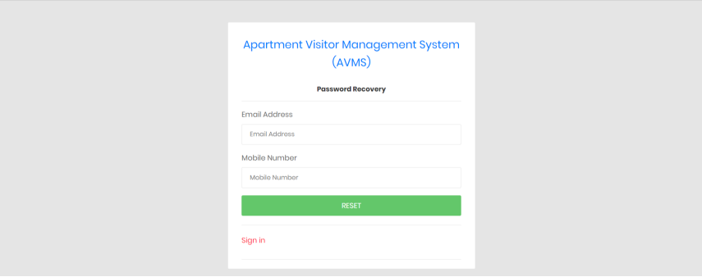

RESET PASSWORD
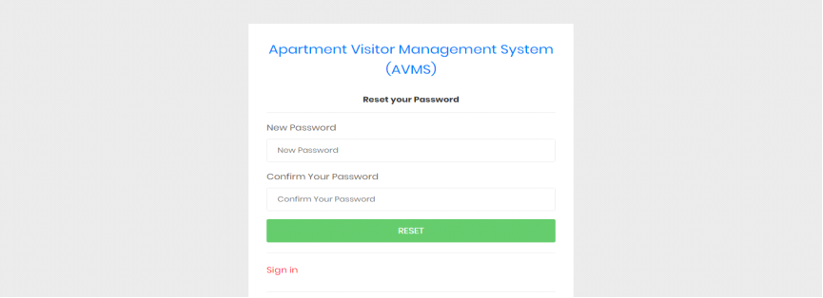

DASHBOARD
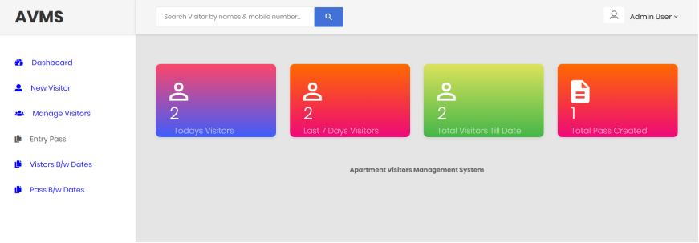

ADMIN PROFILE
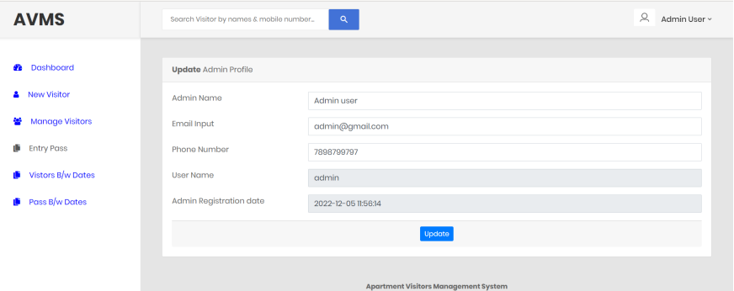

CHANGE PASSWORD
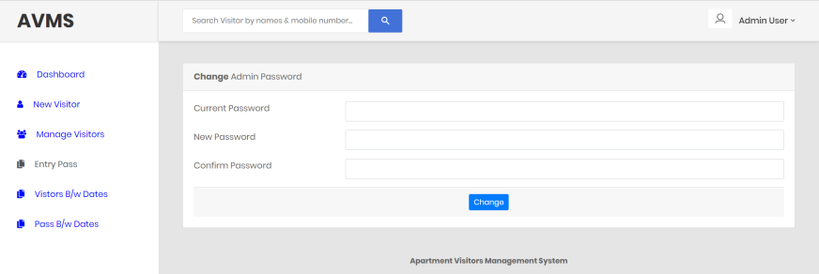

ADD NEW VISITORS
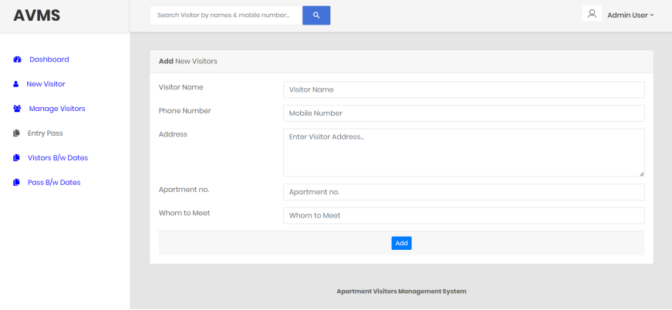

MANAGE VISITORS
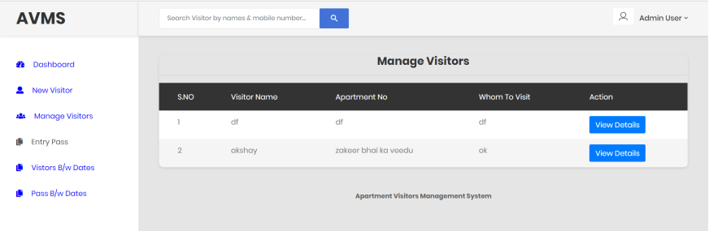

VISITORS DETAILS
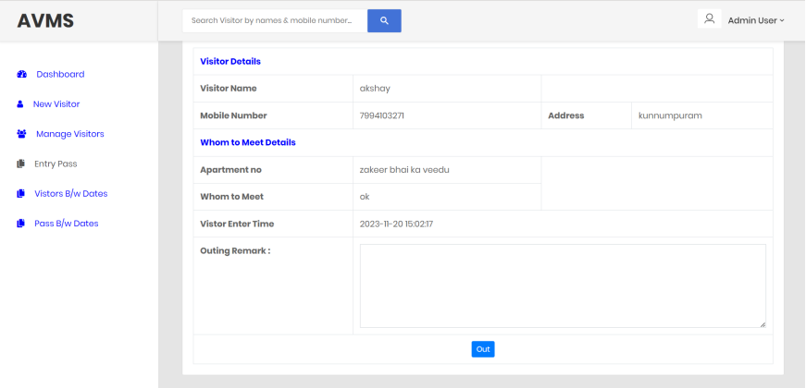

CREATE ENTRY PASS
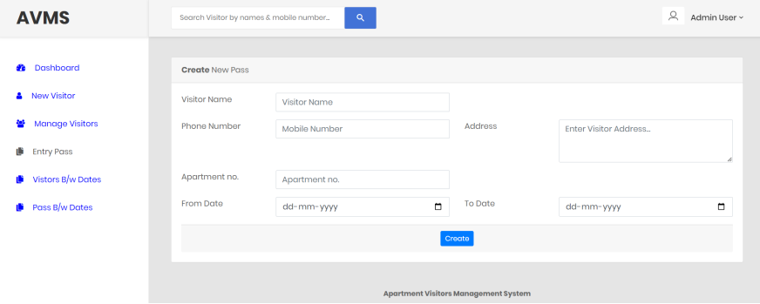

MANAGE ENTRY PASS
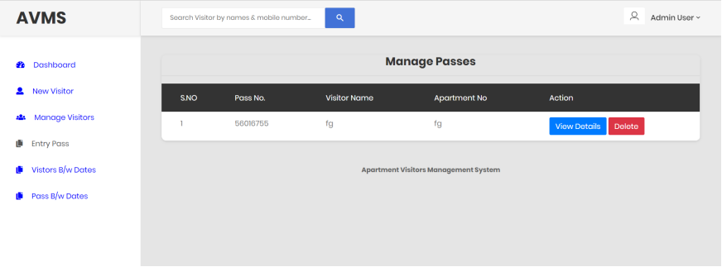

VIEW DETAILS OF ENTRY PASS
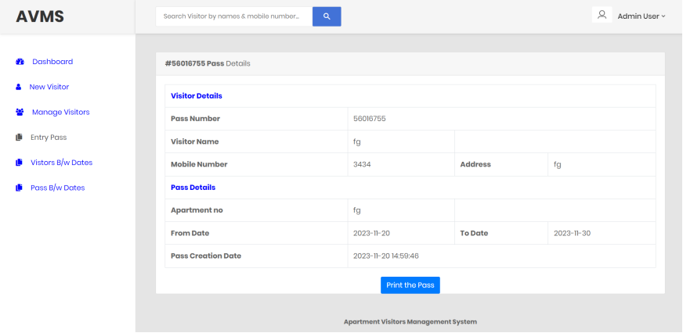

BETWEEN DATES REPORTS
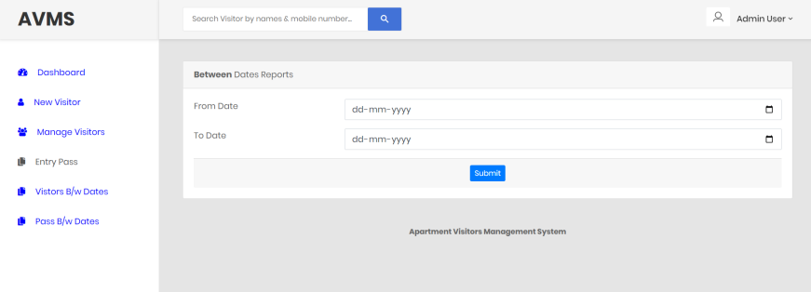

VIEW DETAILS OF BETWEEN DATES REPORTS
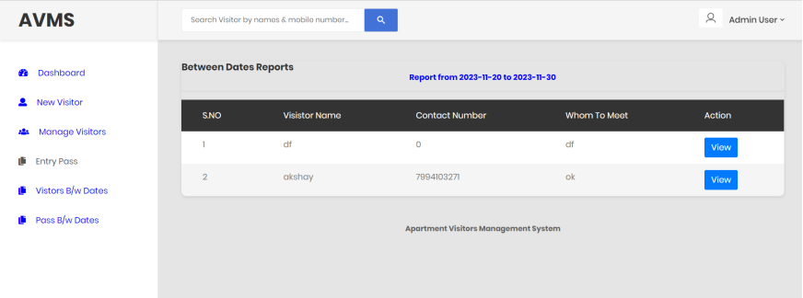

BETWEEN DATES REPORTS OF ENTRY PASS
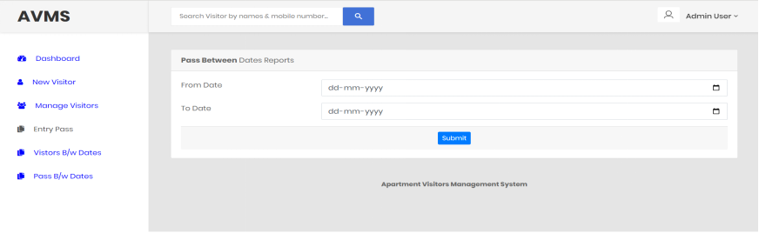

VIEW DETAILS OF BETWEEN DATES REPORT OF ENTRY PASS
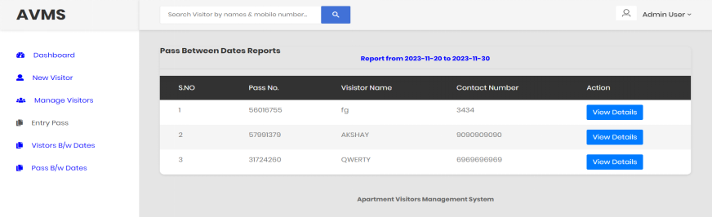

11.2 SAMPLE CODE
Manage-newvisitors.php
<?php
session_start();
error_reporting(0);
include('includes/dbconnection.php');
if (strlen($_SESSION['avmsaid']==0)) {
header('location:logout.php');
} else{

?>

<!DOCTYPE html>
<html lang="en">

<head>
<!-- Required meta tags-->
<meta charset="UTF-8">
<meta name="viewport" content="width=device-width, initial-scale=1, shrink-to-fit=no">
<meta name="description" content="au theme template">
<meta name="author" content="Hau Nguyen">
<meta name="keywords" content="au theme template">

<!-- Title Page-->
<title>AVMS Visitors</title>

<!-- Fontfaces CSS-->
<link href="css/font-face.css" rel="stylesheet" media="all">
<link href="vendor/font-awesome-4.7/css/font-awesome.min.css" rel="stylesheet" media="all">
<link href="vendor/font-awesome-5/css/fontawesome-all.min.css" rel="stylesheet" media="all">
<link href="vendor/mdi-font/css/material-design-iconic-font.min.css" rel="stylesheet" media="all">

<!-- Bootstrap CSS-->
<link href="vendor/bootstrap-4.1/bootstrap.min.css" rel="stylesheet" media="all">

<!-- Vendor CSS-->
<link href="vendor/animsition/animsition.min.css" rel="stylesheet" media="all">
<link href="vendor/bootstrap-progressbar/bootstrap-progressbar-3.3.4.min.css" rel="stylesheet" media="all">
<link href="vendor/wow/animate.css" rel="stylesheet" media="all">
<link href="vendor/css-hamburgers/hamburgers.min.css" rel="stylesheet" media="all">
<link href="vendor/slick/slick.css" rel="stylesheet" media="all">
<link href="vendor/select2/select2.min.css" rel="stylesheet" media="all">
<link href="vendor/perfect-scrollbar/perfect-scrollbar.css" rel="stylesheet" media="all">

<!-- Main CSS-->
<link href="css/theme.css" rel="stylesheet" media="all">

</head>

<body class="animsition">
<div class="page-wrapper">
<!-- HEADER MOBILE-->
<?php include_once('includes/sidebar.php');?>
<!-- END HEADER MOBILE-->

<!-- MENU SIDEBAR-->

<!-- END MENU SIDEBAR-->

<!-- PAGE CONTAINER-->
<div class="page-container">
<!-- HEADER DESKTOP-->
<?php include_once('includes/header.php');?>
<!-- END HEADER DESKTOP-->

<!-- MAIN CONTENT-->
<div class="main-content">
<div class="section__content section__content--p30">
<div class="container-fluid">
<div class="row">
<div class="col-lg-12">
<div class="table-responsive table--no-card m-b-30">
<h3 align="center">Manage Visitors</h3>
<hr />
<table class="table table-borderless table-striped table-earning">
<thead>
<tr>
<tr>
<th width="10">S.NO</th>

<th>Visitor Name</th>

<th>Apartment No</th>
<th>Whom To Visit</th>

<th>Action</th>
</tr>
</tr>
</thead>
<?php
$ret=mysqli_query($con,"select *from tblvisitor");
$cnt=1;
while ($row=mysqli_fetch_array($ret)) {

?>

<tr>
<td><?php echo $cnt;?></td>

<td><?php echo $row['VisitorName'];?></td>

<td><?php echo $row['Apartment'];?></td>
<td><?php echo $row['WhomtoMeet'];?></td>
<td><a href="visitor-detail.php?editid=<?php echo $row['ID'];?>" title="View Full Details" class="btn btn-primary">View Details</a></td>
</tr>
<?php
$cnt=$cnt+1;
}?>
</table>
</div>
</div>

</div>
<?php include_once('includes/footer.php');?>
</div>
</div>
</div>
</div>

</div>
<!-- Jquery JS-->
<script src="vendor/jquery-3.2.1.min.js"></script>
<!-- Bootstrap JS-->
<script src="vendor/bootstrap-4.1/popper.min.js"></script>
<script src="vendor/bootstrap-4.1/bootstrap.min.js"></script>
<!-- Vendor JS -->
<script src="vendor/slick/slick.min.js">
</script>
<script src="vendor/wow/wow.min.js"></script>
<script src="vendor/animsition/animsition.min.js"></script>
<script src="vendor/bootstrap-progressbar/bootstrap-progressbar.min.js">
</script>
<script src="vendor/counter-up/jquery.waypoints.min.js"></script>
<script src="vendor/counter-up/jquery.counterup.min.js">
</script>
<script src="vendor/circle-progress/circle-progress.min.js"></script>
<script src="vendor/perfect-scrollbar/perfect-scrollbar.js"></script>
<script src="vendor/chartjs/Chart.bundle.min.js"></script>
<script src="vendor/select2/select2.min.js">
</script>

<!-- Main JS-->
<script src="js/main.js"></script>

</body>

</html>
<?php } ?>

Search-visitors.php
<?php
session_start();
error_reporting(0);
include('includes/dbconnection.php');
if (strlen($_SESSION['avmsaid']==0)) {
header('location:logout.php');
} else{
?>

<!DOCTYPE html>
<html lang="en">

<head>
<!-- Required meta tags-->
<meta charset="UTF-8">
<meta name="viewport" content="width=device-width, initial-scale=1, shrink-to-fit=no">
<meta name="description" content="au theme template">
<meta name="author" content="Hau Nguyen">
<meta name="keywords" content="au theme template">

<!-- Title Page-->
<title>AVMS Visitors Search</title>

<!-- Fontfaces CSS-->
<link href="css/font-face.css" rel="stylesheet" media="all">
<link href="vendor/font-awesome-4.7/css/font-awesome.min.css" rel="stylesheet" media="all">
<link href="vendor/font-awesome-5/css/fontawesome-all.min.css" rel="stylesheet" media="all">
<link href="vendor/mdi-font/css/material-design-iconic-font.min.css" rel="stylesheet" media="all">

<!-- Bootstrap CSS-->
<link href="vendor/bootstrap-4.1/bootstrap.min.css" rel="stylesheet" media="all">

<!-- Vendor CSS-->
<link href="vendor/animsition/animsition.min.css" rel="stylesheet" media="all">
<link href="vendor/bootstrap-progressbar/bootstrap-progressbar-3.3.4.min.css" rel="stylesheet" media="all">
<link href="vendor/wow/animate.css" rel="stylesheet" media="all">
<link href="vendor/css-hamburgers/hamburgers.min.css" rel="stylesheet" media="all">
<link href="vendor/slick/slick.css" rel="stylesheet" media="all">
<link href="vendor/select2/select2.min.css" rel="stylesheet" media="all">
<link href="vendor/perfect-scrollbar/perfect-scrollbar.css" rel="stylesheet" media="all">

<!-- Main CSS-->
<link href="css/theme.css" rel="stylesheet" media="all">

</head>

<body class="animsition">
<div class="page-wrapper">
<!-- HEADER MOBILE-->
<?php include_once('includes/sidebar.php');?>
<!-- END HEADER MOBILE-->

<!-- MENU SIDEBAR-->

<!-- END MENU SIDEBAR-->

<!-- PAGE CONTAINER-->
<div class="page-container">
<!-- HEADER DESKTOP-->
<?php include_once('includes/header.php');?>
<!-- END HEADER DESKTOP-->

<!-- MAIN CONTENT-->
<div class="main-content">
<div class="section__content section__content--p30">
<div class="container-fluid">
<div class="row">
<div class="col-lg-12">
<div class="table-responsive table--no-card m-b-30">
<?php
if(isset($_POST['search']))
{

$sdata=$_POST['searchdata'];
?>
<h4 align="center">Result against "<?php echo $sdata;?>" keyword </h4>
<hr />

<table class="table table-borderless table-striped table-earning">
<thead>
<tr>
<tr>
<th>S.NO</th>

<th>Visistor Name</th>

<th>Contact Number</th>
<th>Whom to Meet</th>
<th>Action</th>
</tr>
</tr>
</thead>
<?php
$ret=mysqli_query($con,"select *from tblvisitor where VisitorName like '$sdata%'||MobileNumber like '$sdata%'");
$num=mysqli_num_rows($ret);
if($num>0){
$cnt=1;
while ($row=mysqli_fetch_array($ret)) {

?>
<tr>
<td><?php echo $cnt;?></td>

<td><?php echo $row['VisitorName'];?></td>
<td><?php echo $row['MobileNumber'];?></td>
<td><?php echo $row['WhomtoMeet'];?></td>
<td><a href="visitor-detail.php?editid=<?php echo $row['ID'];?>"><i class="fa fa-edit fa- 1x"></i></a></a></td>
</tr>
<?php
$cnt=$cnt+1;
} } else { ?>
<tr>
<td colspan="8"> No record found against this search</td>

</tr>

<?php } }?>
</table>
</div>
</div>
</div>
</div>
</div>
</div>
</div>

</div>
<?php include_once('includes/footer.php');?>
<!-- Jquery JS-->
<script src="vendor/jquery-3.2.1.min.js"></script>
<!-- Bootstrap JS-->
<script src="vendor/bootstrap-4.1/popper.min.js"></script>
<script src="vendor/bootstrap-4.1/bootstrap.min.js"></script>
<!-- Vendor JS -->
<script src="vendor/slick/slick.min.js">
</script>
<script src="vendor/wow/wow.min.js"></script>
<script src="vendor/animsition/animsition.min.js"></script>
<script src="vendor/bootstrap-progressbar/bootstrap-progressbar.min.js">
</script>
<script src="vendor/counter-up/jquery.waypoints.min.js"></script>
<script src="vendor/counter-up/jquery.counterup.min.js">
</script>
<script src="vendor/circle-progress/circle-progress.min.js"></script>
<script src="vendor/perfect-scrollbar/perfect-scrollbar.js"></script>
<script src="vendor/chartjs/Chart.bundle.min.js"></script>
<script src="vendor/select2/select2.min.js">
</script>

<!-- Main JS-->
<script src="js/main.js"></script>

</body>
</html>
<?php } ?>

